THEODORE WIRTH GOLF CLUB

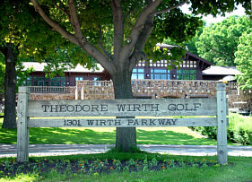

TWGC Member Survey:

Please type under each question listed below your responses. Then save your survey and forward back to the Secretary of TWGC E: dpyle@avistacom.com

- What do you like best about the TWGC? (i.e. what club practices, specific events, formats, etc.) I enjoy the variety of events we play.

- Please list your “Top 3” changes to existing club practices that you feel would have the biggest positive impact in order of preference? More team events, change in 4 somes to get to know other members better, better marked course for yardage and GUR areas.

- Provide any ideas on methods to improve club participation at each event? (i.e. specific event & format changes, tournament fees & payout changes, calendar of event changes, etc.) Many guys seem to only play with certain other guys, meaning the people everyone else plays with seem to be the same from week to week also. I would prefer to play with a larger variety of members each year.

- How can we as a club better promote and acquire new members? Better advertising to the general public when they play at Wirth. I have played many non-club rounds and no one I talk to about the club has heard of it.

- How would you like to become more involved in the club if interested?

- Provide specific ideas and/or initiatives as a club we can do to help improve on the conditions of the golf course? Could the club/course offer free golf to those willing to go out and mark the course or to those willing to go out and repair ball marks on the greens or any other simple maintenance jobs without being an employee?

- What areas can the golf course management and staff improve on to better foster our club and attract new members? Better enthusiasm selling the club to walk up public. Having better on course water/snacks availability, Better publicity of the club within the club house area.

- Please share any other ideas to improve on our club practices, tradition, retention, and club growth?

