The Twin Cities Championship wishes to thank the following tournament sponsors and supporters:
Theodore Wirth Golf Association
Minnesota Golf Association
Minnesota Public Golf Association

______________________________________

Other TCC Tournaments

Junior Championship July 8 Victory Links
Men’s Championship June 29-30 Theodore Wirth and Baker National
Senior Championship July 31 Brackett’s Crossing
Information and applications for these events can be accessed at www.wirthgolfassociation.org/tcc.html

TWIN CITIES CHAMPIONSHIP
Net Four-Ball Division
(Two Person Teams)

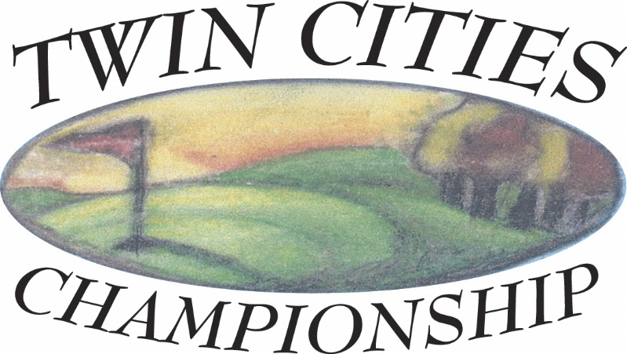

Hiawatha Golf Course
Minneapolis, MN

Saturday, June 29, 2024

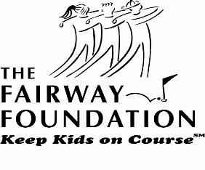
Proceeds to benefit the
Fairway Foundation
www.fairwayfoundation.org

ENTRY DEADLINE: Monday, June 24, 2024
CHAMPIONSHIP PREVIEW
The Twin Cities Championship is a competitive golf tournament for players of all abilities, with top prizes, that raises money for our selected charity, the Fairway Foundation. This organization, created by 3M Championship, the Minnesota Golf Association, and the Minnesota Section of the PGA, introduces inner city youth to golf and the benefits that come with the game. The tournament raises funds to provide opportunity and hope through employment and education to kids who otherwise might not have the chance.

TOURNAMENT FORMAT
The competition will be a net, four-ball event with two person teams playing under the Four-Ball, Stroke Play rules (rule 31). In the case of ties prize money will be split.

ELIGIBILITY
Open to all amateur players with an Official USGA Handicap Index and who are current MGA Associate Members. The USGA’s definition of an amateur golfer is the standard of the Twin Cities Championship. All entries are subject to approval or rejection at any time by the Tournament Committee.

RULES
USGA Rules shall govern play. Local ground rules will be printed and issued to each player.

CARTS
Walking or use of a pull cart is acceptable. Motorized carts can also be used but must be reserved in advance.

ENTRY DEADLINE, ENTRY FEES AND GREENS FEES
Entry forms must be postmarked by Monday, June 24, 2024 or completed online by that date. An entry fee of $100 ($40 if both players are Minneapolis season pass holders, $90 if resident card holders) must accompany the entry form. Late or incomplete entries are not acceptable, nor are entries by telephone or FAX. Entries with insufficient funds will be considered incomplete and will be withdrawn.

STARTING TIMES
Starting times can be obtained after 8 a.m. on Thursday, June 27, 2024, by visiting the TCC website at www.wirthgolfassociation.org/tcc.html and will be emailed to the players,

ENTRY WITHDRAWAL AND REFUNDS
Entry fee will be refunded, regardless of reason, if the Twin Cities Championship Tournament Committee is notified in writing before the close of entries. After the close of entries, the entry fee will be refunded in the event of injury or illness only if the Committee is notified by phone at 612/529-0510 by 4 p.m., Friday, June 28, 2024. If this event is cancelled due to weather, the Tournament Committee will refund all but $20. The $20 will be retained because the primary purpose of this event is to raise money for the charity.

PRIZES
Appropriate merchandise certificates will be awarded as determined by the Tournament Committee. Certificates will be mailed out following the event.

SCORE POSTING
Scores will be posted to the USGA GHIN Handicap System as “T” (Tournament) scores by the Tournament Committee.

Application for Entry
33rd TWIN CITIES CHAMPIONSHIP
Net Four-Ball Division
Hiawatha Golf Course
Player 1

Name: _____________________________________________________________________ (First) (Last)
Address: _____________________________________________________________________
City: ___________________________ State: __________ Zip Code: ____________________
Work Phone: __________________________ Home Phone: ________________________
Member of: _______________________________ Email Address: _____________________

GHIN Number: __ __ __ __ - __ __ __ Handicap Index: ________

Player 2

Name: _____________________________________________________________________
(First) (Last)
Address: _____________________________________________________________________
City: ___________________________ State: __________ Zip Code: ____________________
Work Phone: __________________________ Home Phone: ________________________
Member of: _______________________________ Email Address: _____________________

GHIN Number: __ __ __ __ - __ __ __ Handicap Index: ________

Please reserve a motorized cart for us______

Amateur status: We have read the USGA Rules of Amateur Status and conform with those rules in every respect.

Liability: I acknowledge that the Twin Cities Championship, Hiawatha Golf Course, Theodore Wirth Golf Association, Fairway Foundation, nor the event sponsors are responsible for any injury during the playing of this event.

We agree that this entry is subject to rejection at any time (including during the Championship) by the Tournament Committee. The reason for rejection may include unbecoming conduct.

The Tournament Committee will make the pairings and reserves the right to assign the starting times for the Championship.
Make check payable and mail to:
Twin Cities Championship
P.O. Box 11176
Minneapolis, MN 55411
OR
Sign-up online at mngolf.org

The entry fee is enclosed
Greens fee included.

ENTRY DEADLINE: Mon., June 24, 2024

Player’s signature: ______________________________________________________________

