CHAMPIONSHIP PREVIEW
The Twin Cities Championship is a competitive golf tournament for players of all abilities that raises money for our selected charity, the Fairway Foundation. This organization, created by 3M Championship, the Minnesota Golf Association, and the Minnesota Section of the PGA, introduces inner city youth to golf and the benefits that come with the game.

TOURNAMENT FORMAT
For both boys and girls there will be three age divisions: 12 and under, 13-15, and 16-18. In the 13-15 and 16-18 Divisions the competition will be 18-hole stroke play. In the 12 and under division the competition will be 9-hole stroke play. Ties for first place in the 12 and under and 13-15 age groups will be determined by a scorecard playoff. Ties for first place in the 16-18 Division will be played off immediately, hole by hole, until a champion is determined. For all scorecard playoffs, the Tournament Committee will follow the USGA recommendation of matching scorecards (i.e., final nine, final six, final three, 18th hole, by lot).

ELIGIBILITY
Open to all amateur players of any ability with or without a Handicap Index. Contestants must be 18 years of age or younger on September 1, 2024. The USGA’s definition of an amateur golfer is the standard of the Twin Cities Championship. All entries are subject to approval or rejection at any time by the Tournament Committee.

RULES
USGA Rules shall govern play. Local ground rules will be printed and issued to each player.

CARTS AND CADDIES
Carrying your bag is permissible as is using a pull cart. Caddies are permitted. Motorized carts are not permitted.

ENTRY DEADLINE, ENTRY FEES AND GREENS FEES
Entry forms must be postmarked by Monday, July 1 or completed online by that date. An entry fee of $50 must accompany the entry form. The entry fee includes the greens fee. Late or incomplete entries are not acceptable. Entries by telephone or FAX are not acceptable.

STARTING TIMES
Starting times can be obtained beginning on Wednesday, July 3 from the Twin Cities Championship website, www.wirthgolfassociation.org/tcc.html. and will be emailed to each participant.

ENTRY WITHDRAWAL AND REFUNDS
Entry fee will be refunded, regardless of reason, if the Twin Cities Championship Tournament Committee is notified in writing before the close of entries. After the close of entries, the entry fee will be refunded in the event of injury or illness only if the Committee is notified by phone by 4 p.m. on Sunday, July 7. All withdrawals should contact the Committee at 612/529-0510. If this event is cancelled due to weather, the full entry fee will not be refunded because the primary purpose of this event is to raise money for the charity.

PLAYER POINTS AWARDED
The top three finishers in each of the 16-18 Age divisions will receive MGA Player Points.
1st -25 points 2nd -15 points 3rd-5 points

PRIZES
Appropriate prizes will be distributed at the close of play to high finishers in all divisions.

Application for Entry
33rd TWIN CITIES CHAMPIONSHIP
Boys’ & Girls’ Junior Division
Victory Links at National Youth Golf Center, Blaine
Monday, July 8, 2024

Name: ____________________________________________________________________
(First) (Last)

Address: ________________________________________________________________________

City: ___________________________ State: __________ Zip Code: _____________________

Work Phone: __________________________ Home Phone: ___________________________

Member of: ________________________________________________
(Please indicate if you belong to a club)

GHIN Number: __ __ __ __ - __ __ __ Handicap Index: ________
(Handicap index is not required.)
Please check which applies.
____Male
____Female
Email Address: ________________________________

Date of Birth: ___________

Amateur status: I have read the USGA Rules of Amateur Status. I conform with those rules in every respect.

Liability: I acknowledge that the Twin Cities Championship, Victory Links Golf Course, Theodore Wirth Golf Association, Fairway Foundation, nor the event sponsors are responsible for any injury during the playing of this event.

I agree that this entry is subject to rejection at any time (including during the Championship) by the Tournament Committee. The reason for rejection may include unbecoming conduct.

The Tournament Committee will make the pairings and reserves the right to assign the starting times for the Championship.

The entry fee of $50 is enclosed.

ENTRY DEADLINE: Monday, July 1, 2024

Player’s signature: ____________________________________________________________

Parent’s signature: ________________________________________________
Make check payable and mail to:
Twin Cities Championship
P.O. Box 11176
Minneapolis, MN 55411
OR
Sign-up online at www.mngolf.org

Past Junior Champions
Year Champions
2007 /Stephen Bidne, University G.C. (Boys)
Gretchen Huhnerkoch, University GC (Girls)
2008 Chase Hahne, Links at Northfork (Boys)
Gretchen Huhnerkoch, University G.C. (Girls)

2009 Eric Laorr, Hazeltine G.C. (Boys)
Gretchen Huhnerkoch, University G.C. (Girls)

2010 Tyler Lowenstein, Rush Creek G.C. (Boys)
Anna Laorr, Hazeltine G.C. (Girls)

2011 Max Rosenthal, Bear Path G&C.C. (Boys)
Anna Laorr, Hazeltine C.C. (Girls)

2012 Miles Death, Burl Oaks CC (Boys)
Sarah Burnham, Rush Creek GC (Girls)

2013 Max Mason, Spring Hill GC (Boys)
Sarah Burnham, Rush Creek GC (Girls)

2014 Paul Vogt, Minnesota Valley CC (Boys)
Sarah Burnham, Rush Creek GC (Girls)

2015 Daniel Chi, Rush Creek GC (Boys)
Taylor Ledwein, New Prague GC (Girls)

2016 Peder Larson, Medina GC (Boys)
Anni Heck, Southview GC (Girls)

2017 Jack Peterson, Phelan Park GC (Boys)
Kiera Smith, Fox Hollow GC (Girls)

2018 Austin Howk, Interlachen CC (Boys)
Aayushi Sakara, Eagle Valley GC (Girls)

2019 Nicholas Kauffman, Chaska TC (Boys)
Madison Hicks, Chaska TC (Girls)

2020 Hogan Ordahl, Willingers GC (Boys)
Kathryn Van Arragon, Bunker Hills GC (Girls)

2021 Pranay Singh, Youth on Course (Boys)
Lonnie Veenendall, Youth on Course (Girls)

2022 Carter Stenzel, Winsong Farm (Boys)
Samantha Youngquist, Chaska Town (Girls)

2023 Payton Savageau, Youth on Course (Boys)
Morgan Eckman, Youth on Course (Girls)
,

33rd
TWIN CITIES CHAMPIONSHIP
Boys’ and Girls’ Junior Division

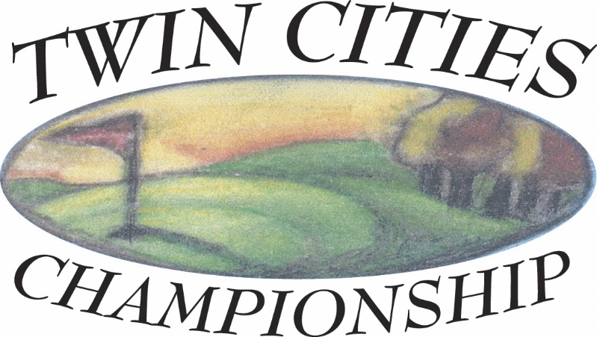

VICTORY LINKS AT
NATIONAL YOUTH GOLF CENTER
Blaine, MN

Monday, July 8, 2024
Proceeds to benefit the
Fairway Foundation
www.fairwayfoundation.org

ENTRY DEADLINE: Monday, July 1, 2024

