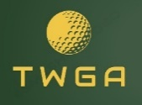

12 MAN AND BEST BALL

SEPTEMBER 22, 2024

RESULTS

1ST GROSS NICK BOHLMAN/DEREK PYLE 69 30 PTS EACH

1ST NET GARY PREVOST/RICK WALD 63 25 PTS EACH

1ST NET ERIC SISLER/DAVE GUNDERSON 63 25 PTS EACH

3RD NET PAT LEARY/SCOTT HELGERSON 65 20 PTS EACH

GROSS SKINS $50 EACH

HELGERSON 2 ON 8

REESE 3 ON 15

NET SKINS $33 EACH

HELGERSON 2 ON 3

TUREK 2 ON 5

REESE 3 ON 15